**Havells India Limited**

Name: Pratik Ravikumar Sanghavi

ID: 2017AAPS0394G

**Section 1: Qualitative Analysis**

**Vision:** To be a globally recognised corporation for excellence, governance, consumer delight and fairness to each stakeholder including the society and Our Mission environment we operate in.

**Mission:** To achieve our vision through business ethics, global reach, technological expertise, building long-term relationships with all our associates, customers, partners and employees.

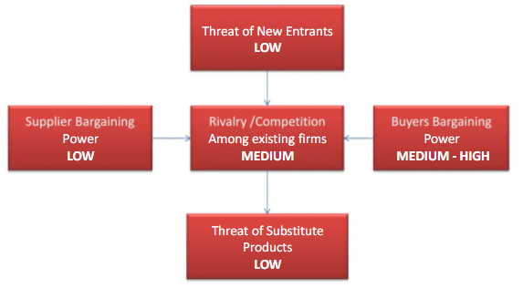**Porter’s Five Force Model:**

Competitors:

Bajaj, Orient Electric, Finolex, Legrand, Anchor-Roma, Phillips, Osram, KEI, Schneider

* Suppliers Bargaining Power: This is relatively low as Havells has the benefit of having in-house manufacturing facilities meaning it has to only buy raw materials. As a result, it is difficult for the supplier to exercise control on the cost structure as raw material prices have low margins compared to finished products
* Buyers Bargaining Power: With a wide variety of options available to choose from, bargaining power of individual buyers is high. The company has attempted to minimize this via sales to construction businesses where the end buyer has no choice and by product customisation strategy in order to differentiate their products.
* Threat of Substitute Products: As a result of product customisation and differentiation as well as construction sector supply contracts, threat of substitution is minimized. Furthermore, it is attempting to create an integrated ecosystem of electrical products that might win them loyal customers in the long run.
* Threat of New Entrants: As a large-scale manufacturing giant, threat of new entrants is minimised as entry costs are very high. Moreover, Havells has a robust distribution network which will be difficult for new players to acquire.
* Rivalry among existing firms: Havells has established itself in a niche by diversification into related businesses and hence has managed to keep competition at a moderate level.

**Business Strategy Analysis (Competitive and Corporate):**

1. Havells possesses a world-class infrastructure with a global presence with one of the largest manufacturing capacities in India.
2. It has invested heavily in its brand image over the years and has even opened ‘Havells Galaxy’ retail stores pan-India as a one stop shop for Havells products.
3. Havells has retained a 20% stake in Sylvania Lighting International and has plans for acquisitions of Chinese firms having already opened a representative office under Havells Guangzhou International Limited.
4. With prominent brands under its wing such as Lloyd, Crabtree, Standard, Reo and several more, it has expanded into a wide range of Fast-Moving Electrical Products. The diversification strategy includes operational relatedness so that its sub-brands can share the financial, intellectual and other resources of its parent.
5. Its dedicated R&D wing specialises in low energy and eco-friendly lighting solutions (best in industry) and relevant international certifications and is well poised to capture this fast-growing market.
6. Its switch gears are ready for factory deployment out of the box helping them gain share in a market filled with predecessor variants (Blue Ocean Strategy).
7. It has also attempted to attract consumers via low margins, direct replacement and customisation options (price as well as product differentiation).
8. Furthermore, it has forayed into air conditioners, washing machines, water purifiers and more recently refrigerators which indicate its intention for product diversification.

**BCG Matrix:**

|  |  |  |
| --- | --- | --- |
| **Product line** | **Revenue Mix** | **Revenue Mix(in %)** |
| Switchgears | 370.27 | 15.10221229 |
| Cable | 784.67 | 32.00435605 |
| Lighting & Fixtures | 264.57 | 10.79102359 |
| Electrical Cons. Durables | 579.87 | 23.65117303 |
| Lloyd Consumer | 280.44 | 11.4383137 |
| Others | 171.94 | 7.01292133 |
|  | 2451.76 | 100 |

The pie chart derived from the quarterly report (Sep 30, 2020) of Havells India clearly shows its revenue streams from various segments. Since these percentage distributions remain more or less constant over the past year quarterly reports, we can arrive at the following BCG matrix:

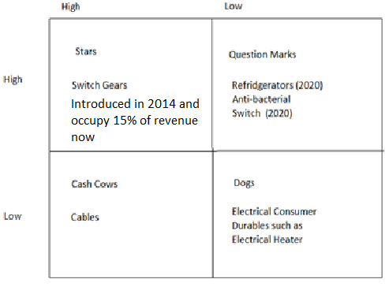

**Section 2: ROE Decomposition**

Return on Equity Decomposition:

Net interest expense after tax (NIE) =

(Interest expense – Interest income)*(1-Tax Rate)

NOPAT = Net Income + NIE

C&MS

LTB Repaid (Cash flow statement reveals no repayment of short term borrowings)

Operating Working Capital (OWC)=

(CA – C&MS) – (CL –LTB Repaid)

Net Assets = Net long term assets + OWC

Net debt = Total interest bearing liabilities – C&MS

Operating ROS = NOPAT/Sales

Net Assets Turnover = Sales / Net Assets

Operating ROA = Operating ROS* Net Assets Turnover

Effective interest rate after tax (R) = Net debt / NIE

Net financial leverage = Net debt / Equity

Return on Equity = Operating ROA +

Net financial leverage*(Operating ROA – R)

|  |  |
| --- | --- |
| **Term** | **Value** |
| Net Income | 735.35 |
| Interest Expenses | 5.17 |
| Interest Income | 62.46 |
| Applicable Tax Rate | 0.25168 |
| Net Interest expense after tax | -42.871253 |
| NOPAT | 692.47875 |
| Current Assets | 3460.84 |
| Current Liabilities | 2326.9 |
| Cash and Marketable Securities | 267.7 |
| Repayment of long term borrowings | 54 |
| Operating Working Capital | 920.24 |
| Net long term assets | 3592.81 |
| Net Assets | 4513.05 |
| Total Interest Bearing Liabilities | 40.5 |
| Net debt | -227.2 |
| Sales | 9407.1 |
| Operating ROS | 0.0736124 |
| Net Assets Turnover | 2.0844218 |
| Operating ROA | 0.1534392 |
| Effective interest rate after tax | 0.1886939 |
| Equity | 4311.56 |
| Net financial leverage | -0.0526955 |
| Return on Equity | 0.155297 |
| Return on Equity (in %) | 15.53% |



The Operating ROA is nominally greater than the ROE which results from a negative debt. This arises from the Cash and Marketable securities being greater than the total interest bearing liabilities resulting in a negative net financial leverage. The firm is thus majorly reliant on equity for financing its expansion plans.

The Operating Working Capital is roughly 20% of the net assets which is typical for a capital intensive firm like Havells which is heavily reliant on a fixed asset base.

Another figure that comes to the fore is the Net Assets turnover. With a Net Assets Turnover of about 2.08, it is evident that Havells is able to efficiently utilise its assets in generating revenue. This is very rare for capital intensive firms. However, the low levels of ROS indicate an increasing reliance on cost leadership strategy to maximize sales.

**Valuation of Havells India Limited**

1. Beta Calculation of Havells:

Unlevered beta = 1.152945 (Calculation in excel sheet attached)

|  |  |
| --- | --- |
| Covariance with Index | 33.55789 |
| Variance of index | 29.10623 |
| Unlevered Beta of Havells | 1.152945 |
| Debt/Equity ratio | 0.009393 |
| Tax rate | 0.25168 |

Applicable Tax Rate = 25.168%

Long Term Debt = 40.5

Equity Capital = 4311.56

Debt/Equity Ratio = 0.009393

Levered beta = Unlevered beta * (1 + (1 – Tax rate)*D/E)

Levered beta = Unlevered beta

Levered beta = 1.152945

1. Cost of equity calculation:

CAPM Model used; it is assumed that unsystematic risk

averted by diversification

Risk free rate (Rf)= 5.83% (10 year government securities rate)

Rm = 8.501905% (Average return of NSE index)

Cost of equity = Rf + (levered beta*(Rm-Rf))

Cost of equity = 8.910561%

1. Weighted Average Cost of Capital (Details given in the WACC Calculation spreadsheet):

As per CARE ratings, Havells has a rating of AAA



Cost of debt = Risk free rate + Default spread

Cost of debt = 10-year government securities rate + spread of AAA rated bonds

AAA bond spread = 1.09%

Pre-tax Cost of Debt = 6.92%

After Tax Cost of Debt = 5.178%

[](https://www.moneycontrol.com/financials/havellsindia/consolidated-ratiosVI/hi01#hi01)

The relatively constant leverage coupled with the fact that beta of the company is close to 1 (as with Toyota) enables us to use the FCFE approach to value the firm in which the rate of discounting:

Rate of discounting = Cost of Equity

Rate of discounting = 8.910561%

1. Growth Rate Calculation:

Non-Cash ROE Equity Reinvestment Rate

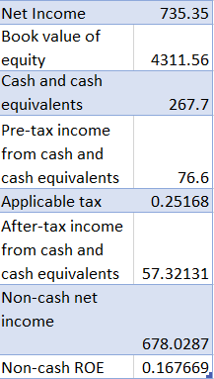

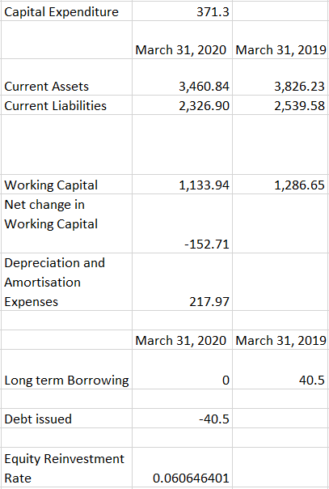

It is worth noting that in 2020, the company has had a dividend payout ratio of 72.33% as sharp contrast from the usual dividend payout ratio in the last 5 years which usually lay around 30%. This might indicate an effect of the coronavirus pandemic and needs to be corrected. I will assume that Non-cash ROE remains relatively constant as can be seen from the trends of the previous years. The equity reinvestment rate will vary across a period of 5 years before settling to a stable value.

In the current year

Growth rate = 1.0169%

1. Stable period equity reinvestment rate:

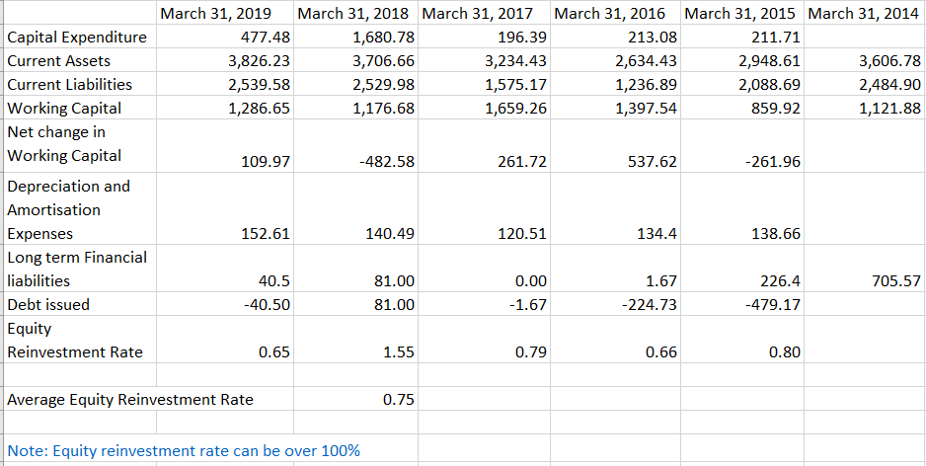

Over past 5 years, company has grown at an average rate: -

Average growth rate in 5 years = 12.6018%

1. Normalised Net income:

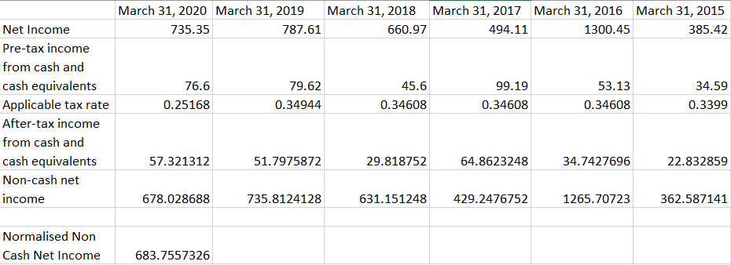

1. Free Cash Flow to Equity Projections:

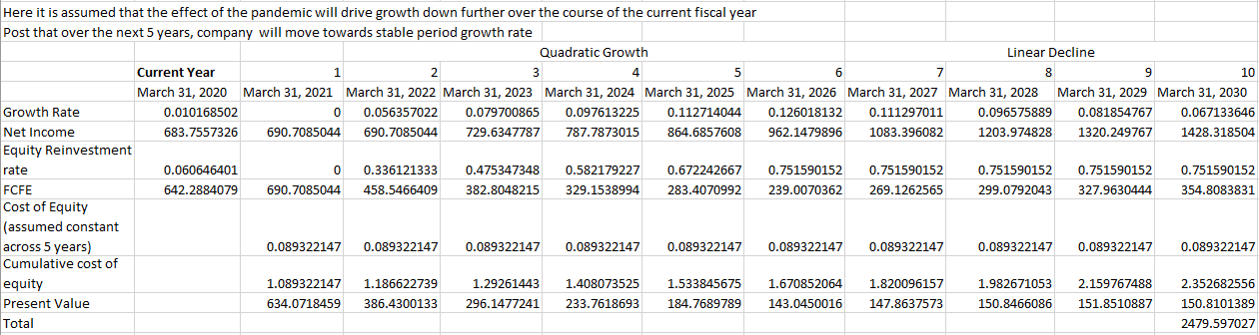

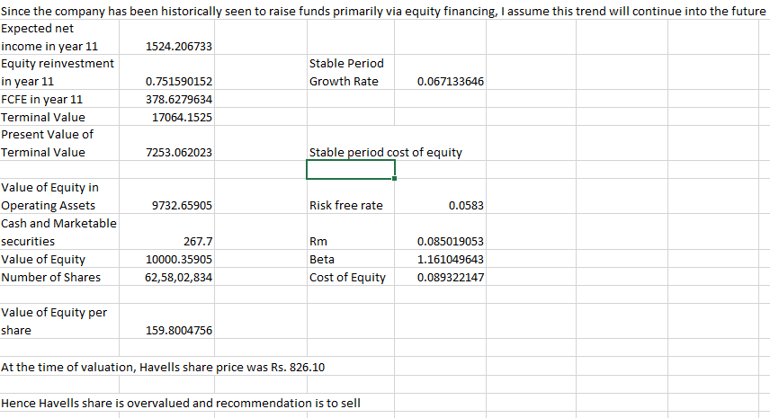

Now while such high disparity between intrinsic value (159.8) and share price (826.10) seems anomalous, various online resources arrive at intrinsic values between 125-188. Therefore, the share is grossly overvalued. As per some resources online, there has been insider trading which may explain such behaviour.

Online resources with similar valuations:

<http://www.attainix.com/ICTrackerDetail.aspx?stockcode=HAVELLS.IN>

<https://billiondollarvaluation.com/havells-valuation-excel-model-and-intrinsic-value-of-shares/?amp>

<https://simplywall.st/stocks/in/capital-goods/nse-havells/havells-india-shares>

<https://www.gurufocus.com/term/iv_dcf_share/NSE:HAVELLS/Intrinsic-Value-Projected-FCF/Havells-India-Ltd>



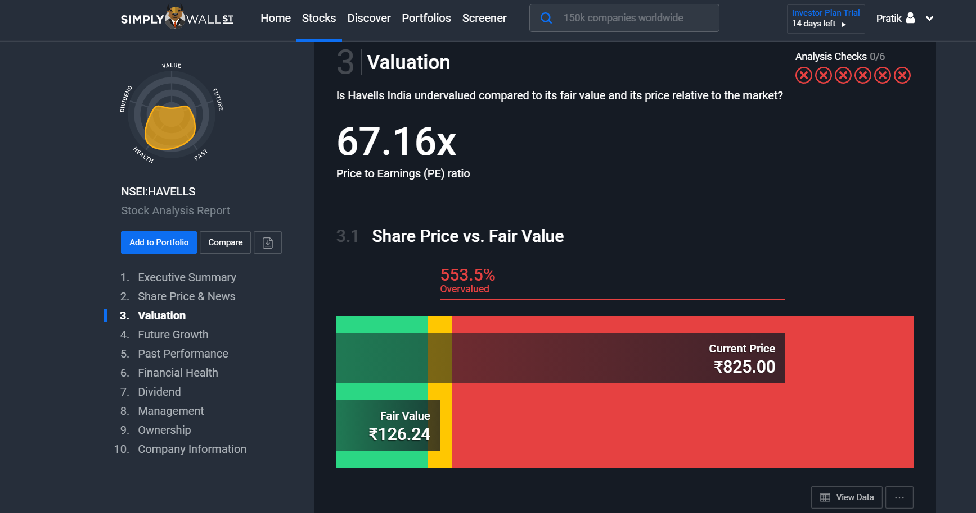

**References:**

1. <https://www.havells.com/en/discover-havells/investor-relation/financials/annual-reports.html>
2. <https://www.moneycontrol.com/financials/havellsindia/consolidated-ratiosVI/hi01/1#hi01>
3. <https://www.slideshare.net/mbabrothers/havells-india-limited>
4. <http://www.attainix.com/ICTrackerDetail.aspx?stockcode=HAVELLS.IN>
5. <https://billiondollarvaluation.com/havells-valuation-excel-model-and-intrinsic-value-of-shares/?amp>
6. <https://simplywall.st/stocks/in/capital-goods/nse-havells/havells-india-shares>
7. <https://www.gurufocus.com/term/iv_dcf_share/NSE:HAVELLS/Intrinsic-Value-Projected-FCF/Havells-India-Ltd>
8. <https://www.tickertape.in/stocks/havells-india-HVEL>